**DAILY ONLINE ACTIVITIES SUMMARY**

|  |  |  |  |  |  |  |  |  |
| --- | --- | --- | --- | --- | --- | --- | --- | --- |
| **Date:** | **10/06/2020** | | | | | **Name:** | **RITIKA KULKARNI** | |
| **Sem& Sec** | **4thSEM. & ‘B’ SEC.** | | | | | **USN:** | **4AL19CS403** | |
| **Online Test Summary** | | | | | | | | |
| **Subject** | | **OBJECT ORIENTED CONCEPT** | | | | | | |
| **Max. Marks** | | **30** | | **Score** | | | **14** | |
| **Certification Course Summary** | | | | | | | | |
| **Course** | **Introduction of Cyber Security** | | | | | | | |
| **Certificate Provider** | | | **Greatlearning**  **Academy** | | **Duration** | | | **5 Hrs.** |
| **Coding Challenges** | | | | | | | | |
| **Problem Statement:**   1. **Given a matrix, the task is to print the boundary elements of the matrix and display their sum.**   **Sample Output 1:**  **Enter M (Rows) and N (Columns): 3, 3**  **Enter the Elements: 1 2 3 4 5 6 7 8 9**   1. **Java Program to find the longest repeating sequence in a string**   **string:acbdfghybdf** | | | | | | | | |
| **Status: Executed** | | | | | | | | |
| **Uploaded the report in Github** | | | | | **Yes** | | | |
| **If yes Repository name** | | | | | <https://github.com/ritikakulkarni> | | | |
| **Uploaded the report in slack** | | | | | **Yes** | | | |

**Online Test Summary: 18CS43 test was scheduled from 9:15 am to 9:50 am. The portion for the IA was 4th module there were 15 questions and the time assigned was 30 minutes the questions were mcq type. But there was an issue with the time mentioned, so that we got only 30mins. to finish the test. The time was not sufficient to answer all the questions. There were 15 questions of 2 marks respectively.**

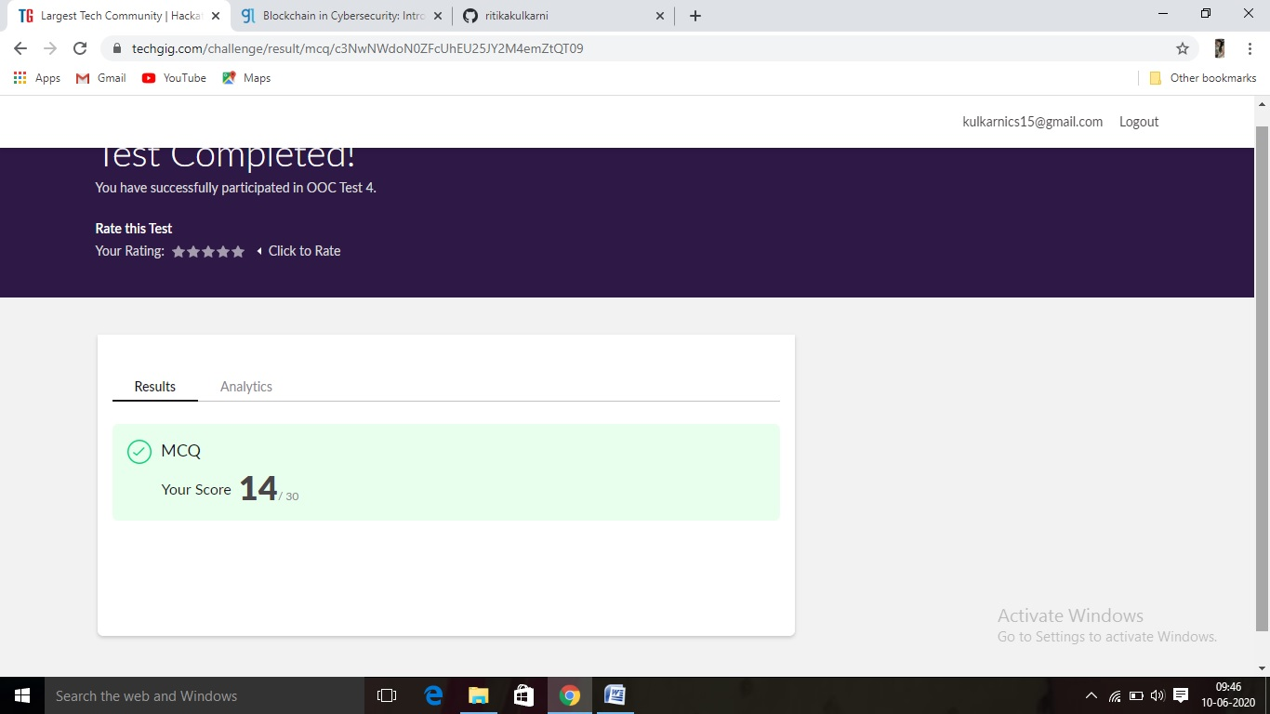

**Certification Course Summary: Today, I learnt Introduction of Cyber security and**

**About blockchain and so on. I didn’t complete Information security course because of some issues that’s why I changed the course.**

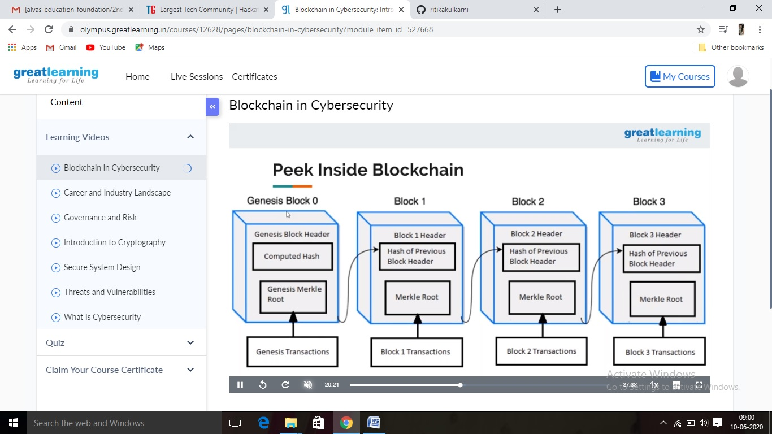

**Online Coding Summary:Online Coding Summary​: Online coding Summary: Today I received two program from Prof.Venkatesh and reenalobo CSE Dept. The program is mentioned above(pg.01). to my GitHub repository and I’ve shared the snapshot below.**

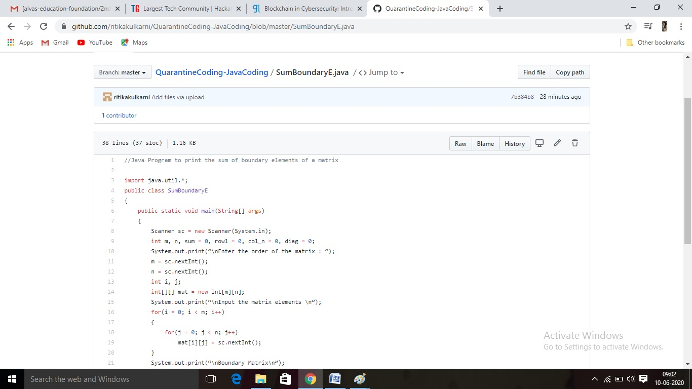

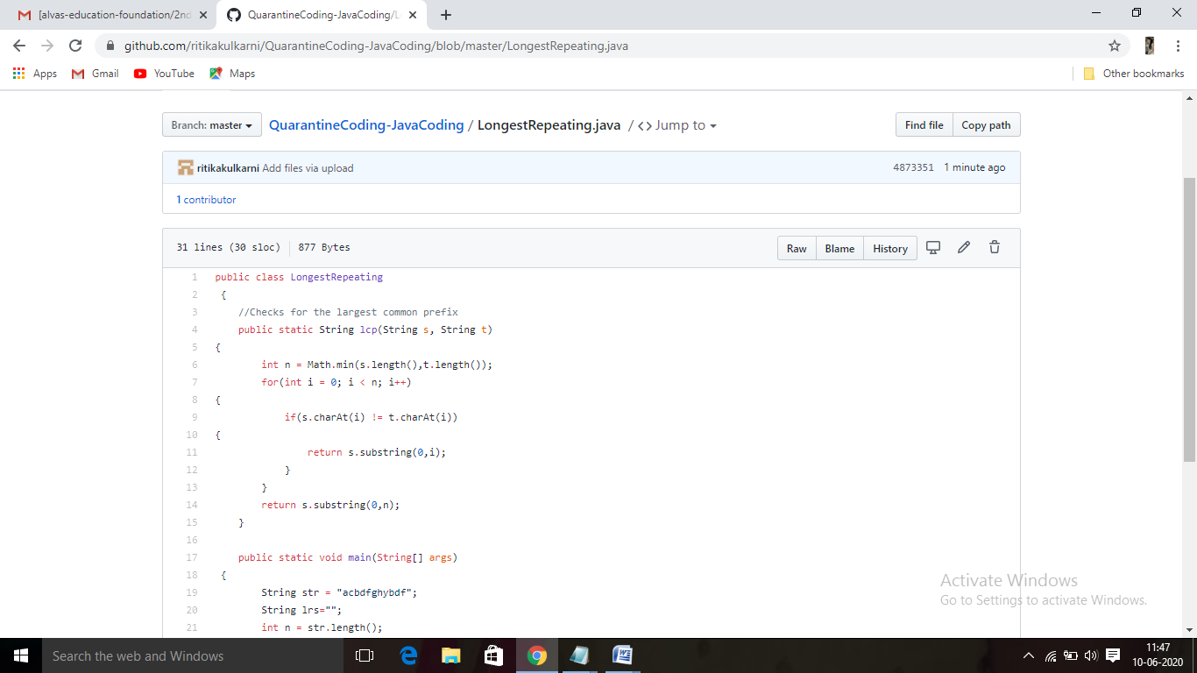

**Thank you.**